**UNIVERSITY-BANGLADESH**

Choose an item.

**Lab Report**

|  |  |  |  |  |
| --- | --- | --- | --- | --- |
| Assignment Title: | Lab Report | | | |
| Assignment No: | 3 | | Date of Submission: | 16 February 2021 |
| Course Title: | Data Communication | | | |
| Course Code: | 00068 | | Section: | J |
| Semester: | Spring | 2020-21 | Course Teacher: | Md Mehedi Hasan |

**Declaration and Statement of Authorship:**

1. I/we hold a copy of this Assignment/Case-Study, which can be produced if the original is lost/damaged.
2. This Assignment/Case-Study is my/our original work and no part of it has been copied from any other student’s work or from any other source except where due acknowledgement is made.
3. No part of this Assignment/Case-Study has been written for me/us by any other person except where such collaborationhas been authorized by the concerned teacher and is clearly acknowledged in the assignment.
4. I/we have not previously submitted or currently submitting this work for any other course/unit.
5. This work may be reproduced, communicated, compared and archived for the purpose of detecting plagiarism.
6. I/we give permission for a copy of my/our marked work to be retained by the Faculty for review and comparison, including review by external examiners.
7. I/we understand thatPlagiarism is the presentation of the work, idea or creation of another person as though it is your own. It is a formofcheatingandisaveryseriousacademicoffencethatmayleadtoexpulsionfromtheUniversity. Plagiarized material can be drawn from, and presented in, written, graphic and visual form, including electronic data, and oral presentations. Plagiarism occurs when the origin of them arterial used is not appropriately cited.
8. I/we also understand that enabling plagiarism is the act of assisting or allowing another person to plagiarize or to copy my/our work.

*\* Student(s) must complete all details except the faculty use part.*

** Please submit all assignments to your course teacher or the office of the concerned teacher.

|  |  |  |  |  |  |  |  |
| --- | --- | --- | --- | --- | --- | --- | --- |
| **No** | **Name** | **ID** | | **Program** | | **Signature** | |
| 1 | Md.Yousuf Afendi | 19-39887-1 | | BSc [CSE] | |  | |
| ***Faculty use only*** | | | | | | |
| FACULTYCOMMENTS | | | **Marks Obtained** | |  | |
|  | | |  | |  | |
|  | | |  | |  | |
|  | | | **Total Marks** | |  | |
|  | | |  | |  | |
|  | | |  | |  | |

2.d)

Id:19-39887-1

A=1,B=9,C=3,D=9,E=8,F=8,G=7,H=1

A1=GD=79, A2=AF=18

pkg load communications

fs = 10000;

t = -1:1/fs:100-1/fs;

C=3;

F=8;

A1=79;

A2=18;

x1 = 20*cos(2 * pi *(C * 100)*t ) ;

x2 = 16*cos(2 * pi *(F * 100)*t ) ;

x3 = x1 + x2 ;

sig=x3(1:200);

time=t(1:200);

xmin=min(x3);

xmax=max(x3);

line=linspace(xmin,xmax,6);

partition=[(line(1)+line(2))/2,(line(2)+line(3))/2,(line(3)+line(4))/2,(line(4)+line(5))/2,(line(5)+line(6))/2];

codebook=linspace(xmin,xmax,6);

[index,quants]=quantiz(sig,partition,codebook);

figure

plot(time,sig,'k',time,quants,'-','LineWidth',2)

xlabel('Time');

ylabel('Signal Magnitude');

title('Orginal & Quantized signal');

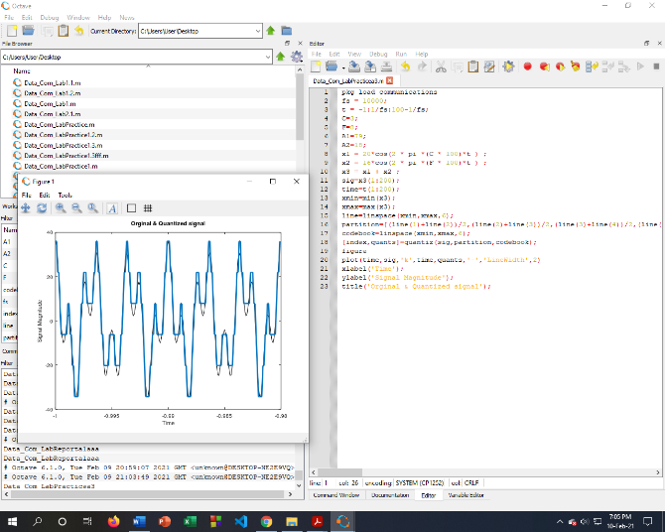

3. Id:19-39887-1

x1(t) = A1 cos(2π(CDE*100)t )

A=1,B=9,C=3,D=9,E=8,F=8,G=7,H=1

1. A1=GD=79, A2=AF=18

b)

(1) A1=79;

A2=18;

CDE=398;

fs=40000;

t=0:5/fs:5-5/fs;

x1=A1*cos(2*pi*(398*100)*t);

n=4;

L=(2^n)-1

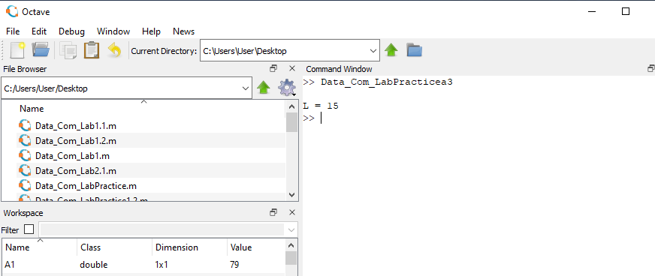

(2) A1=79;

A2=18;

CDE=398;

fs=40000;

t=0:5/fs:5-5/fs;

x1=A1*cos(2*pi*(CDE*100)*t);

n=4;

L=(2^n)-1;

delta= (max(x1)-min(x1))/L

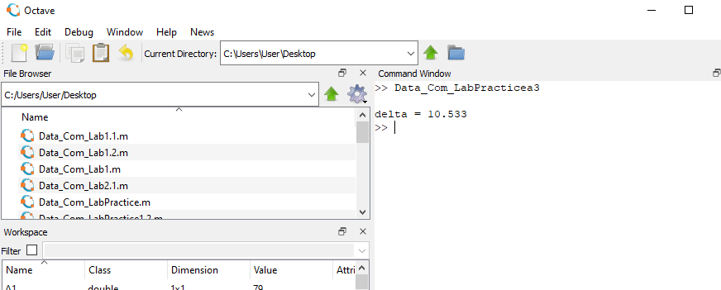

(3) A1=79;

A2=18;

CDE=398;

fs=40000;

t=0:5/fs:5-5/fs;

x1=A1*cos(2*pi*(CDE*100)*t);

x=3.2;

n=4;

L=(2^n)-1;

delta= (max(x1)-min(x1))/L;

xq=min(x1)+(round((x-min(x1))/delta)).*delta

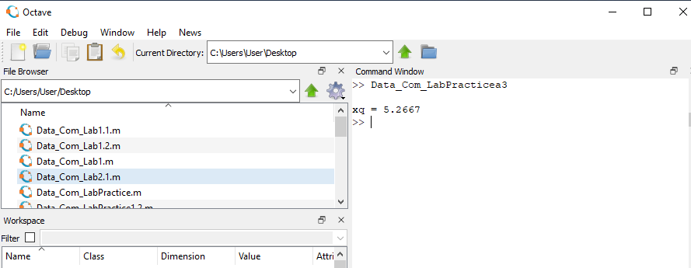

(d) A1=79;

A2=18;

CDE=398;

fs=80000;

t=0:1/fs:0.005;

x1=A1*cos(2*pi*(CDE*100)*t);

x=3.2;

n=4;

L=(2^n)-1;

delta= (max(x1)-min(x1))/L;

xq=min(x1)+(round((x1-min(x1))/delta)).*delta;

B = dec2bin((round((x1-min(x1))/delta)))

fid = fopen('binary.txt' , 'w')

fprintf(fid, [repmat('%c',1,size(B,2)) '\r\n'], B.')

fclose(fid)

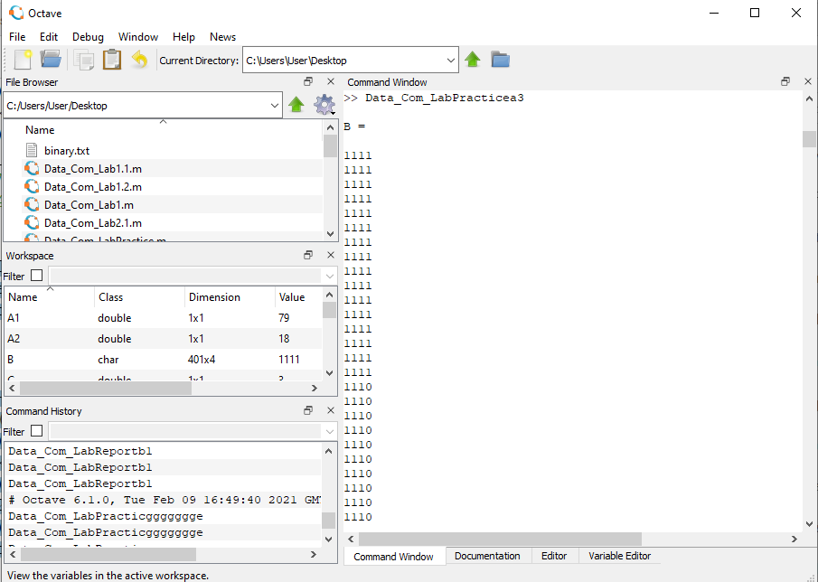 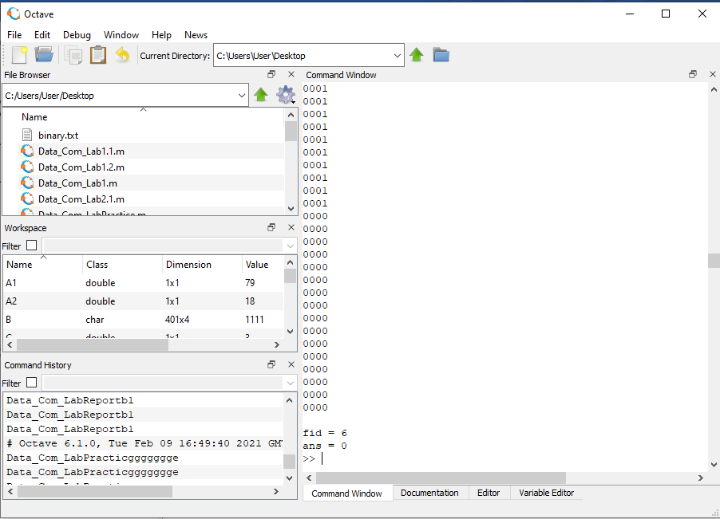

(5) A1=79;

A2=18;

CDE=398;

fs=80000;

t=0:1/fs:0.005;

x1=A1*cos(2*pi*(CDE*100)*t);

x=3.2;

n=4;

L=(2^n)-1;

delta= (max(x1)-min(x1))/L;

xq=min(x1)+(round((x1-min(x1))/delta)).*delta;

subplot(3,1,1)

plot(t,x1,'r');

subplot(3,1,2);% breaking the window figure to plot both graphs

stem(t,x1,'k');% plot of discrete time signaltitle('Discrete time representation')% title of the figure

xlabel('time(s)')% label on the x-axis of the plot

ylabel('X[n]')% label on the y-axis of the plot

subplot(3,1,3);

stairs(t,xq,'b');% the quantized output

title('Quantized Signal')% title of the figure

xlabel('time')% label on the x-axis of the plot

ylabel('amplitude')% label on the y-axis of the plot

